TASK 1

abstract class vehicle{  
 String make**;** String model**;** Integer year**;** public vehicle() {  
 }  
 public vehicle(String make**,** String model**,** Integer year) {  
 this.make = make**;** this.model = model**;** this.year = year**;** }  
 public abstract double getSalePrice()**;** public abstract String display()**;**}  
class car extends vehicle{  
 int baseprice**;** int curryear=**2023;** public car() {  
 }  
 public car(String make**,** String model**,** Integer year**,**int baseprice) {  
 super(make**,** model**,** year)**;** System.*out*.println("\nThis is Car\n")**;** this.baseprice=baseprice**;** }  
 public double getSalePrice(){  
 double salesprice**;** if ((curryear-year)<**3**){  
 salesprice = baseprice\***1.2;** return salesprice **;** }  
 else if ((curryear-year)>=**3**||(curryear-year)<=**10**){  
 salesprice = baseprice\***0.9;** return salesprice **;** }  
 else salesprice =baseprice\***0.5;** return salesprice**;** }  
 public String display(){  
 return "Make is "+make+"\nModel is "+model+"\nYear is "+year+"\nSales price is "+getSalePrice()**;** }  
}  
class truck extends vehicle{  
 int baseprice**;** float weightCapacity**;** public truck(String make**,** String model**,** Integer year**,** int baseprice**,** float weightCapacity) {  
 super(make**,** model**,** year)**;** System.*out*.println("\nThis is Truck\n")**;** this.baseprice = baseprice**;** this.weightCapacity = weightCapacity**;** }  
 public truck() {  
 }  
 @Override  
 public double getSalePrice() {  
 double salesprice**;** if (weightCapacity<**2000**){  
 salesprice = baseprice+**5000;** return salesprice**;** }  
 else if (weightCapacity>=**2000**||weightCapacity<=**5000**){  
 salesprice=baseprice+**10000;** return salesprice**;** }  
 else salesprice = baseprice+**20000;** return salesprice**;** }  
 public String display(){  
 return "Make is "+make+"\nModel is "+model+"\nYear is "+year+"\nWeight Capacity is "+weightCapacity+"\nPrice is "+getSalePrice()**;** }  
}  
class MAIN {  
 public static void main(String[] args) {  
 vehicle v1 = new car("Honda"**,**"Ciaz"**,2019,100000**)**;** System.*out*.println(v1.display())**;** vehicle v2 = new truck("Ford"**,**"Rocket"**,1998,500000,3500**)**;** System.*out*.println(v2.display())**;** }  
}

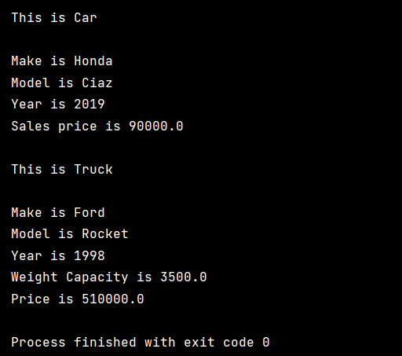

TASK 2

abstract class charater{  
 Integer health**;** Integer attackPower**;** String name**;** public abstract void specialAbility()**;** public charater(Integer health**,** Integer attackPower**,** String name) {  
 this.health = health**;** this.attackPower = attackPower**;** this.name = name**;** }  
  
 public int attack(charater obj){  
 this.health=health- obj.attackPower**;** return this.health**;** }  
}  
class warrior extends charater{  
 public warrior(Integer health**,** Integer attackPower**,** String name) {  
 super(health**,** attackPower**,** name)**;** }  
  
 @Override  
 public void specialAbility() {  
 attackPower=attackPower\***2;** }  
}  
class mega extends charater{  
 public mega(Integer health**,** Integer attackPower**,** String name) {  
 super(health**,** attackPower**,** name)**;** }  
  
 @Override  
 public void specialAbility() {  
 attackPower=attackPower+**20;** }  
}  
class archer extends charater{  
 public archer(Integer health**,** Integer attackPower**,** String name) {  
 super(health**,** attackPower**,** name)**;** }  
  
 @Override  
 public void specialAbility() {  
 attackPower=attackPower+**15;** }  
}  
public class Main {  
 public static void main(String[] args) {  
 System.*out*.println("Hello world!")**;** charater c1= new warrior(**300,50,**"KALI")**;** charater c2 = new mega(**200,60,**"MARKY")**;** charater c3 = new archer(**100,80,**"DEED")**;** System.*out*.println("Warrior attacks mega")**;** c1.attack(c2)**;** System.*out*.println("Warrior's health is "+c1.health)**;** c1.attack(c3)**;** System.*out*.println("Warrior's health is "+c1.health)**;** c2.specialAbility()**;** c1.attack(c2)**;** System.*out*.println("Warrior's health is "+c1.health)**;** }  
}

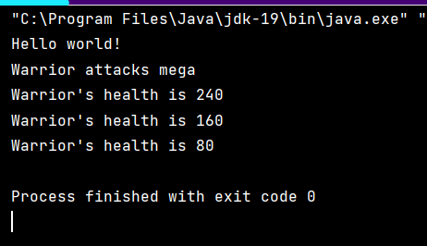

TASK 3

interface MessageService{  
 public void send(String message**,**String recipient)**;** public String receive()**;**}  
class WhatsApp implements MessageService{  
 String message**;** @Override  
 public void send(String message**,** String recipient) {  
 this.message=message**;** System.*out*.println(message)**;** System.*out*.println(recipient)**;** }  
 @Override  
 public String receive() {  
 return message**;** }  
}  
public class Main {  
 public static void main(String[] args) {  
 System.*out*.println("Hello world!")**;** WhatsApp w1 = new WhatsApp()**;** w1.send("Try not to contact me "**,**"Partham")**;** System.*out*.println(w1.receive())**;** }  
}

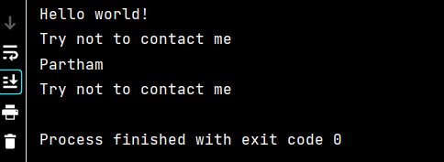

TASK 3

interface shape{  
 public double gerarea()**;** public double getPerimeter()**;**}  
class rectangle implements shape{  
 int legth**,**width**;** double area**,**perimeter**;** public rectangle(int legth**,** int width) {  
 this.legth = legth**;** this.width = width**;** }  
  
 @Override  
 public double gerarea() {  
 area=width*legth**;** return area**;** }  
  
 @Override  
 public double getPerimeter() {  
 perimeter =**2**\*(legth+width)**;** return perimeter**;** }  
}  
class circle implements shape{  
 double radius**,**area**,**perimeter**;** public circle(double radius) {  
 this.radius = radius**;** }  
  
 @Override  
 public double gerarea() {  
 area = (**3.14**)*radius*radius**;** return area**;** }  
  
 @Override  
 public double getPerimeter() {  
 perimeter = **2**\*(**3.14**)*radius**;** return perimeter**;** }  
}  
public class Main {  
 public static void main(String[] args) {  
 System.*out*.println("Hello world!")**;** rectangle r1 = new rectangle(**20,10**)**;** System.out.println("Area of rectangle is "+r1.gerarea())**;** System.out.println("Perimeter of rectangle is "+r1.getPerimeter())**;** circle c1= new circle(**3.0**)**;** System.out.println("Area of circle is "+c1.gerarea())**;** System.out.println("Perimeter of circle is "+c1.getPerimeter())**;** }  
}

